Module: BIT PROJECT

PROJECT PROPOSAL

Module Lecture: Mr Gondwe

Student Name: William C. Lubaini

# Table of Contents

Contents

Table of Contents 2

**Online Wholesalers Management System** 3

Summary 3

Background 3

Problem Description 3

Aim 3

Objectives 3

Key Words 4

Methodologies 4

Structure Model 1 5

Structure Model 2 6

Project Plan 7

Conclusion 7

References 7

# **Online Wholesalers Management System**

# Summary

The project focuses on developing a website that will help clients to place orders online and will also develop a database system that will be used to keep records of products, to keep track of customer records and other necessary information for the organization. Goods can either be purchased online or at the local building of the organizations.

# Background

At H.B wholesalers company currently do not have a website and they do not also keep track of customers records or customer’s transaction process but it deals with large number of customers. Orders are placed within the building hence leads to overcrowd within the building and customers wait for their items to be organized and collected hence this process consumes a lot of their customer’s time.

# Problem Description

* Customers place orders within the building and this process takes a lot of time to be done and number of customer’s keep on increasing within the building which this leads to overcrowd.
* Customers wait for items or groceries to be organized and collected hence their time is always consumed.
* The company do not keep track of customers.
* The company do not have a website.
* The company do not use modern database system.

# Aim

* To design a web-based system that will facilitate business process for wholesalers and to make their business more efficient.

# Objectives

* To develop a website that should allow customers to place orders or purchase online.
* To develop a database system that should be able to:
* Store customer’s information and goods available at the organization.
* Store transaction process done online by customers.
* Show orders placed by customers on the website.
* It should be able to allow customers to access on Desktop computers and On Phone because it will use Bootstrap (Programming language) to run on the front-end of the website.
* The website will use programming languages such as JavaScript, MySQL, jQuery and PHP to run on the following platforms: front-end and back-end. Combination of these programming languages will form a powerful web-based system that it will be able to carry out automated tasks such as: storing transaction process done online by customers into the database system, recording customer’s information automatically into the database system and showing items available in the database system on the website.

# Key Words

* OOM (Object – Oriented Methodologies)
* SSADM (Structured System Analysis and Design)
* DFD (Data Flow Diagram)
* ERD (Entity Relationship Diagram)

# Methodologies

* The system approach that will use is OOM because this method is good for database design and website design hence this is appropriate method for the system because the system only requires a database system and a website.
* OOM Promotes the reuse of components rather than SSADM.
* OOM approach provides simplicity, Reuse of code and design, Easily maintainable and Maintainable.

# Structure Model 1

* This section presents DFD and shows how the system works.

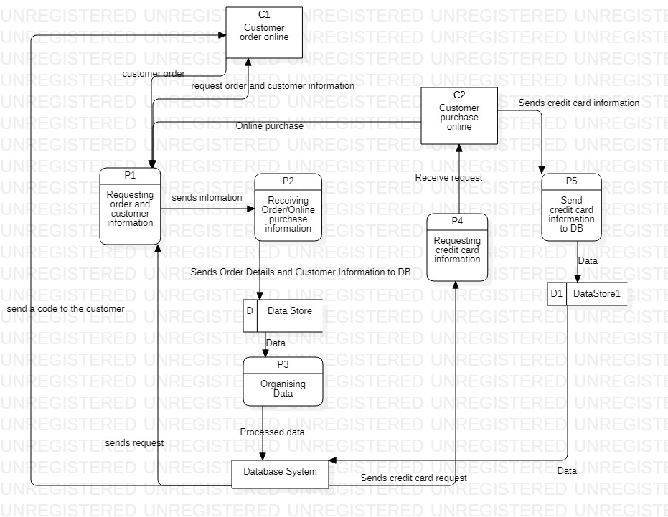

# Structure Model 2

* This section shows detailed ERD of the whole system.

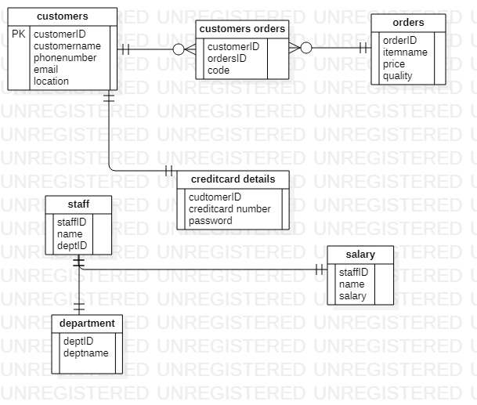

# Project Plan

|  |  |  |
| --- | --- | --- |
| **What To Do?** | **Work To Be Carried Out** | **Start Date – End Date** |
| 1. Requirements | 1. Establishment of requirements. | 2 March 2020 – 7 March 2020 |
| 1. Analysis | 1. Analyzing requirements. | 16 March 2020 – 23 March 2020 |
| 1. Design | 1. Designing how website will look like. 2. How the database will be designed. | 23 March 2020 – 25 March 2020 |
| 1. Coding | 1. Actual coding using all required languages for the project. | 26 March 2020 – 12 April 2020 |

# Conclusion

The project will help wholesalers to facilitate their business processes hence time will be saved and used wisely in the end.

# References

Dawson, C. (2009). *Projects In Computing and Information Systems: A student’s Guide.* Pearson Addison Wesley.

Wybolt, N. (n.d.). *Experience With C++ and Object Oriented software development. SIGSOFT.*